CRAFTS, FASHION & TEXTILES
Craft Entrepreneur - Student Worksheet

Coming up with your product idea – 15 mins:
Brainstorm:
What product could you put to a different use, give it a new purpose? Which two materials could you put together to make a new household item or accessory?
What currently gets thrown away that could be repurposed?
What could you upcycle or downcycle?

For example:  Plastic bags have been used as the raw material to weave baskets, tote bags, placemats and much more. | 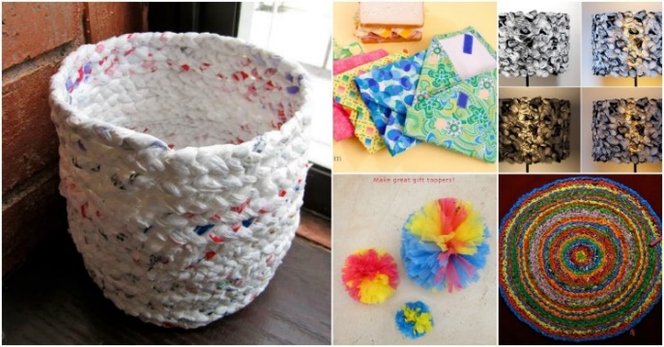
What craft or skill will you be working with?
Consider raw materials you can sustainably source – textiles, second-hand clothes, plastic recycling, fizzy drink cans, glass bottles, old bedding, buttons, old furniture, newspaper, vintage crockery or glassware – how could they be repurposed? Remade using craft into something completely new?
If you can’t decide which idea to go with, discuss each in relation to questions below, and take a vote.
Prepare 2 min presentation – 15 mins:
- What’s your idea called? What is it? What craft/skill underpins the creative business idea?
- What is the rationale behind your concept – who is the target customer, why would they want it?
- How is it sustainable/does it help the planet?
- How much do you think you could charge? What would be your main costs? Would you be able to make a profit?

Rehearse your 2 min presentation – 10 mins:
Team of four – 30 seconds approx. contribution from each person – divide up the questions above

